Date: /09/2026
Aim of the Experiment:
Interfacing of LEDs with Arduino Uno.
Objective:
- To familiarize with Arduino UNO Microcontroller: The Brain of an Embedded System.
- To build our first external circuit and control it from the Arduino
- To create a two-LED circuit that blinks alternatively.
- Create an Arduino Sketch to light up three LEDs in sequence for one second.
- Adaptation of a simple 4-bit LED binary counter.

Components/Equipment Required:

Sl No. | Name of the Component/Equipment | Specification | Quantity
1 | Arduino UNO R3 | 16MHz | 1
2 | Arduino UNO cable | USB Type A to B | 1
3 | Resistors (carbon type) | ¼ watt (330Ω) | 4
4 | LED | Red, Blue, Green, White | As per the requirement
5 | Breadboard | 840 Tie points | 1
6 | Jumper Wire | ----------------------- | As per the requirement

Objective 1

Circuit Diagram(TinkerCAD):

Code/Program:

Observation :

Objective 2

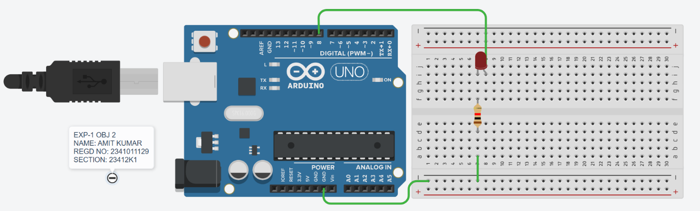
Circuit/Schematic Diagram:
Code:

Observation: The Arduino UNO commands the LED (connected to Digital Pin 8 via a resistor) to continuously blink on and off alternatively with the delay of 1 sec.

Objective 3

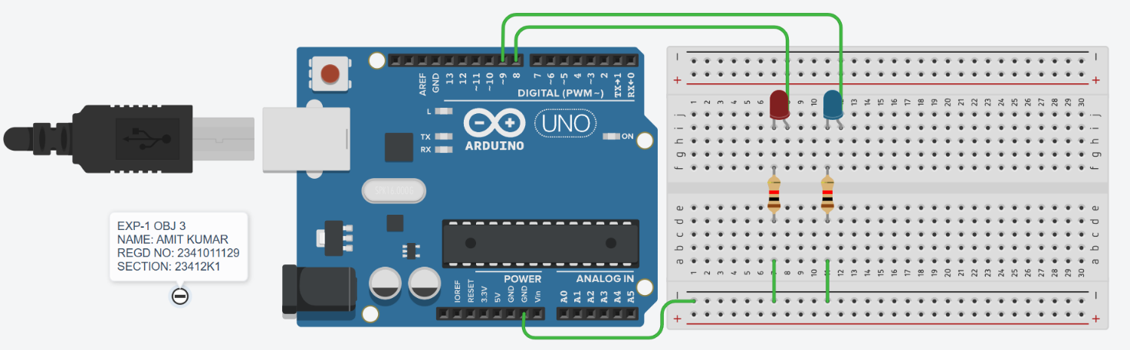
Circuit/Schematic Diagram:

Code:

Observation: The Arduino UNO commands the two LEDs (connected to Digital Pins 8 and 9 via resistors) to continuously blink on and off alternatively with the delay of 1 sec.

Objective 4

Circuit/Schematic Diagram:
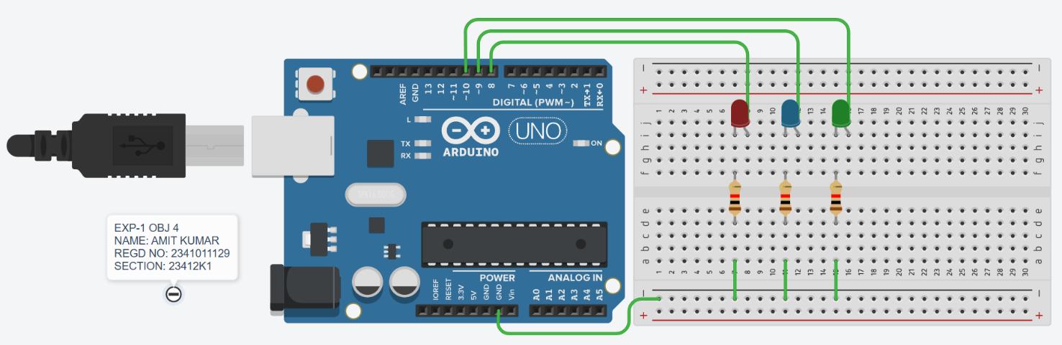
Code:

Observation: The Arduino UNO commands the three LEDs (connected to Digital Pins 8, 9, and 10 via resistors) to continuously blink on and off sequentially with a delay of 1 sec.

Objective 5

Circuit/Schematic Diagram:
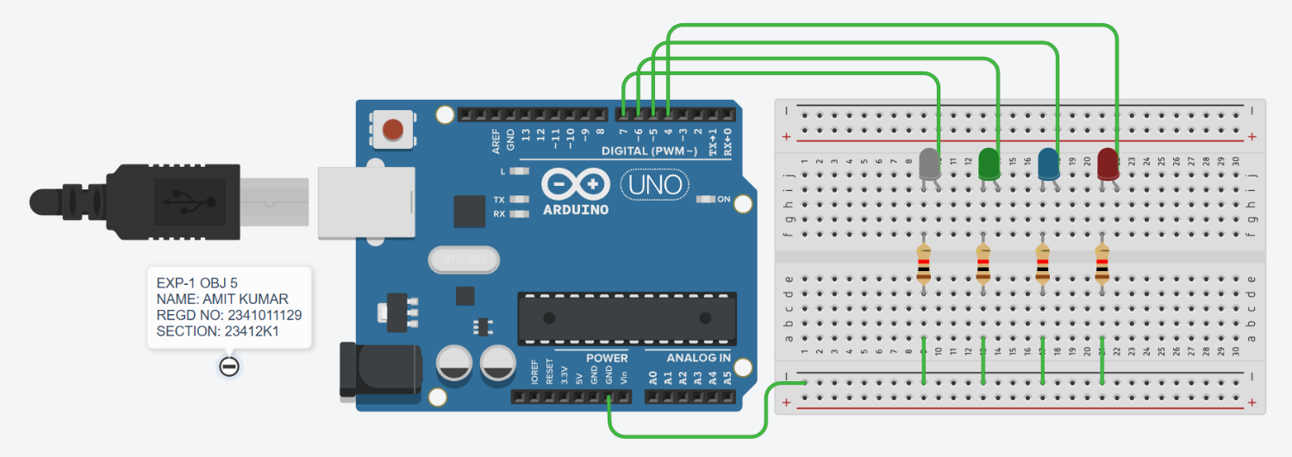

Code:

Observation: The Arduino UNO commands the four LEDs (connected to Digital Pins 4, 5, 6, and 7 via resistors) to act as a 4-bit binary counter, sequentially turning on and off to display the binary equivalents of the numbers 0 through 15 with a delay of 1 second between each count.

Post Experiment Questionnaire:
- List out the different types of Arduino boards available in the market and give one specific application of each board.
Sol^{n}- Arduino UNO : General-purpose prototyping and beginner DIY projects
Arduino Mega 2560 : Complex projects requiring a large number of inputs and outputs
Arduino Nano : Compact, space-constrained, or breadboard-based circuits
Arduino Leonardo : Emulating computer peripherals like custom keyboards or mice
Arduino Due : Projects requiring high-speed processing and complex calculations
Arduino MKR WiFi 1010 : Internet of Things (IoT) and wireless networking applications

- What are PWM pins in Arduino? How many PWM pins are present in Arduino UNO?
Sol^{n}- PWM (Pulse Width Modulation) pins are digital pins capable of generating pseudo analog output signals by rapidly toggling a digital signal high and low, varying the duty cycle (the percentage of time the signal remains HIGH) to control the average voltage delivered to a load.
The Arduino UNO features 6 PWM pins (specifically digital pins 3, 5, 6, 9, 10, and 11, typically denoted by a tilde ~ on the board).

- Can we give power supply to the Arduino Uno through USB connection and DC power barrel jack simultaneously? Justify your answer.
Sol^{n}- Yes, they can be connected simultaneously.
Justification: The Arduino UNO has a built-in automatic power switching circuit. It prioritizes the DC barrel jack over the USB connection. If the barrel jack voltage is sufficient (above ~6.6V), the board automatically disconnects the USB power line. This prevents power collisions and safely protects your computer's USB port from reverse current.

- Which voltage regulator is present in Arduino module?
Sol^{n}- The standard Arduino UNO module primarily uses the following linear voltage regulators:
- 5V Regulator: NCP1117ST50T3G (commonly identified as AMS1117-5.0 or LM1117-5.0 on many boards). This steps down the external power from the barrel jack to a stable 5V.
- 3.3V Regulator: LP2985-33DBVR. This steps down the 5V supply to provide a stable 3.3V output for low-voltage components.

- Explain what is the need for an infinite loop in embedded systems?
Sol^{n}- An infinite loop (like the loop() function in Arduino) is required in embedded systems for three main reasons:
- Continuous Operation: Embedded devices (like digital watches or temperature sensors) are designed to run their dedicated task continuously until they are powered off.
- No Operating System to Exit To: Unlike PC programs that close and return to a desktop, bare-metal microcontrollers have no operating system. If the program ends, the processor halts, and the device stops working entirely.
- Constant Monitoring: The loop allows the system to continuously check sensor inputs, process information, and update outputs in real-time.

- How to minimize the number of pins required to connect more number of LEDs.
Sol^{n}- To minimize the number of pins required to connect multiple LEDs, you can use the following techniques:
- Multiplexing: Arranging LEDs in a matrix to control $R×C$ LEDs using just $R+C$ pins (Rows + Columns).
- Charlieplexing: Utilizing the tri-state logic (HIGH, LOW, and High-Impedance) of microcontroller pins to control $N\left(N-1\right)$ LEDs using only $N$ pins.
- Shift Registers (e.g., 74HC595): Using an IC to convert serial data into parallel output, allowing you to control 8 or more LEDs using just 3 pins (Data, Clock, Latch).
- Addressable LEDs (e.g., WS2812B): Daisy-chaining LEDs with built-in microchips, requiring only 1 digital data pin to control hundreds of LEDs.
- Dedicated LED Drivers (e.g., MAX7219): Using communication protocols like I2C or SPI to control large LED arrays using just 2 to 4 pins.

Name of the Student: Amit Kumar
Registration No: 2341011129
Branch and Section: CSE - 23412K1

